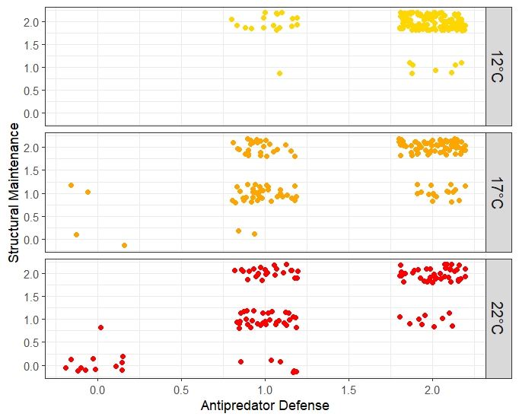

Figure S1: Scatter plot displaying the relationship between sea cucumber stiffness metrics. Spearman’s rank correlation coefficient indicated a high degree of correlation between metrics (r = 0.53, p < 0.001)

Table S1: Results from AIC model selected top ordinal regression model examining the effect of treatment and date on sea cucumber antipredator defense stiffness.

|  |  |  |  |  |
| --- | --- | --- | --- | --- |
| Variable | Coefficient | Standard error | T | P |
| Treatment: 17C | -3.03 | 0.748 | -4.07 | 4.80e-05 |
| Treatment: 22C | -4.76 | 0.818 | -5.82 | 5.88e-09 |
| Date: Nov 10 | -3.09 | 0.634 | -4.86 | 1.16e-06 |
| Date: Nov 11 | -3.39 | 0.643 | -5.28 | 1.33e-07 |
| Date: Nov 12 | -3.00 | 0.632 | -4.75 | 2.06e-06 |
| Date: Nov 13 | -3.62 | 0.664 | -5.45 | 5.05e-08 |

Table S2: Results from AIC model selected top ordinal regression model examining the effect of treatment and date on sea cucumber structural maintenance stiffness.

|  |  |  |  |  |
| --- | --- | --- | --- | --- |
| Variable | Coefficient | Standard error | T | P |
| Treatment: 17C | -2.99 | 0.575 | -5.20 | 1.99e-07 |
| Treatment: 22C | -4.05 | 0.606 | -6.68 | 2.44e-11 |
| Date: Nov 10 | -0.976 | 0.524 | -1.86 | 0.0627 |
| Date: Nov 11 | -2.30 | 0.528 | -4.35 | 1.37e-05 |
| Date: Nov 12 | -2.22 | 0.527 | -4.21 | 2.50e-05 |
| Date: Nov 13 | -2.12 | 0.541 | -3.93 | 8.66e-05 |

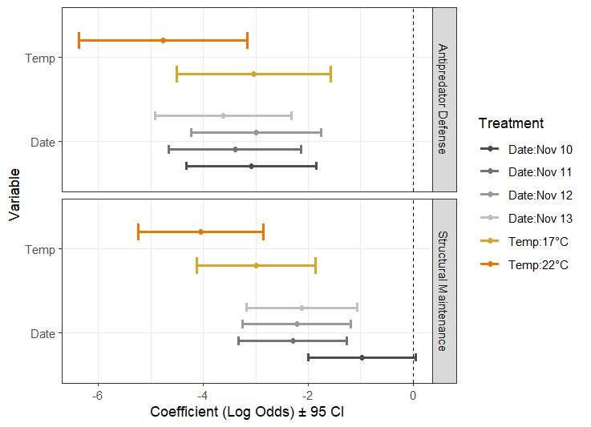

Figure S2. Ordinal regression output from two AIC selected models with stiffness as antipredator defense or structural maintenance as the response variable. Variable reference categories were Date: Nov 09 and Temp: 12°C.

Table S3. Results from multiple kruskal-wallis tests used to compare activity scores across treatments for the day preceeding, the first day of, the day after and seven days after heat treatment.

|  |  |  |  |
| --- | --- | --- | --- |
| Day | Kruskal-Wallis chi-square | df | P (not adjusted) |
| 1 (pre-treatment) | 2.28 | 2 | 0.319 |
| 2 | 6.21 | 2 | 0.0448 |
| 5 (initial recovery) | 3.55 | 2 | 0.169 |
| 12 (delayed recovery) | 1.81 | 2 | 0.16 |

Table S4. Results from Dunn test of multiple comparisons between temperature treatments on day 2 of the experiment. P values were adjusted for multiple comparisons using the Holm method.

|  |  |  |
| --- | --- | --- |
| Comparison | Z | P. adjusted |
| 12C - 17C | 0.540 | 0.589 |
| 12C - 22C | 2.39 | 0.0506 |
| 17C - 22C | -1.87 | 0.124 |

Table S5: Results from the backward-selected zero-adjusted negative binomial regression model examining the effect of treatment and date on sea cucumber activity scores. The final model only included the date variable.

|  |  |  |  |  |
| --- | --- | --- | --- | --- |
| Variable | Coefficient | Standard error | T | P |
| (intercept) | 1.78 | 0.0740 | 24.05 | < 2e-16 |
| Date: Nov 10 | 0.0279 | 0.109 | 0.257 | 0.797 |
| Date: Nov 11 | -0.289 | 0.112 | -2.58 | 0.0105 |
| Date: Nov 12 | -0.331 | 0.109 | -3.03 | 0.00274 |
| Date: Nov 13 | -0.328 | 0.126 | -2.60 | 0.00991 |

DELCAN WRITE A CAPTION

|  |  |  |  |  |
| --- | --- | --- | --- | --- |
|  | Estimate | Std. Error | t-value | P-value |
| poop0 (Intercept) | 1.7126 | 1.1281 | 1.518 | 0.135 |
| poop1 | -2.780 | 1.1202 | -2.482 | 0.0163 * |
| weight_g | -0.004309 | 0.002029 | -2.124 | 0.0383 * |

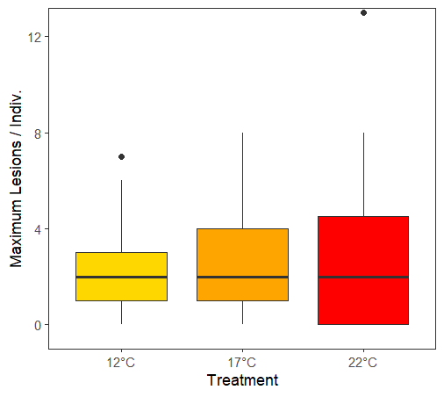

Figure S3. Maximum number of minor lesions per sea cucumber over temperature treatments.

Table S7: Results from geometric regression model examining the effect of treatment and weight on sea cucumber maximum lesion counts.

|  |  |  |  |  |
| --- | --- | --- | --- | --- |
| Variable | Coefficient | Standard error | T | P |
| (intercept) | 0.649 | 0.581 | 1.12 | 0.269 |
| Weight | 0.0004 | 0.0009 | 0.458 | 0.649 |
| Treatment : 17°C | 0.0171 | 0.387 | 0.044 | 0.965 |
| Treatment: 22°C | -0.331 | 0.411 | 0.319 | 0.751 |

MORE FIGS

